**AWS Cloud Solution Architecture**

**Hands-on Projects**

**By**

**Manoj Mareedu**

Table of Contents

Lab Chapter 1: 3

Lab Chapter 2: 4

Lab Chapter 3: 6

Lab Chapter 4: 8

Lab Chapter 5: 10

Lab Chapter 6: Lambda Lab 13

Lab Chapter 7: Step Function Lab 14

Lab Chapter 8: Create a Redis Cluster 17

Lab Chapter 9. Create Mysql database. 20

Lab Chapter 10: Cashing 22

Lab Chapter 16: Build, Train, and Deploy a Machine Learning Model with Amazon Sage Maker. 23

# Lab Chapter 1:

* Captured Ec2 Metrics.

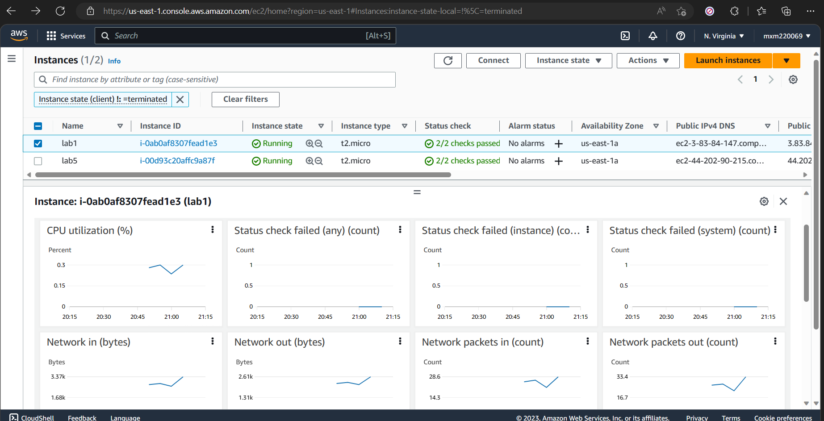

1. Step 5. Captured the Alarm state for selected metrics.

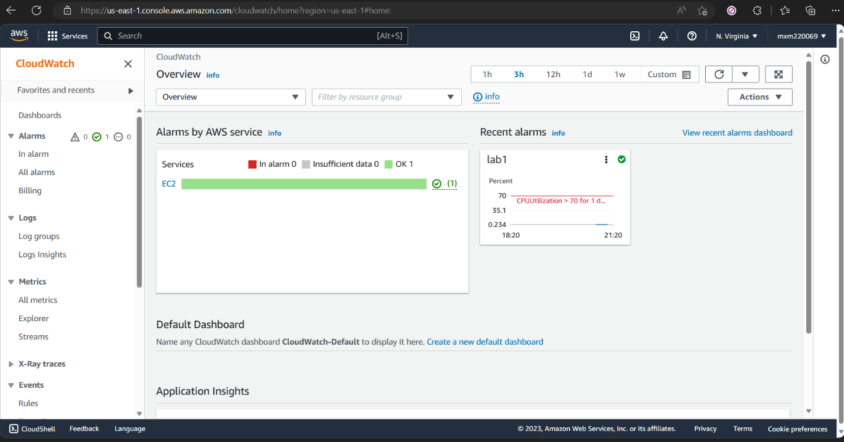

1. Step 7. Captured the Cross Service Dashboard.

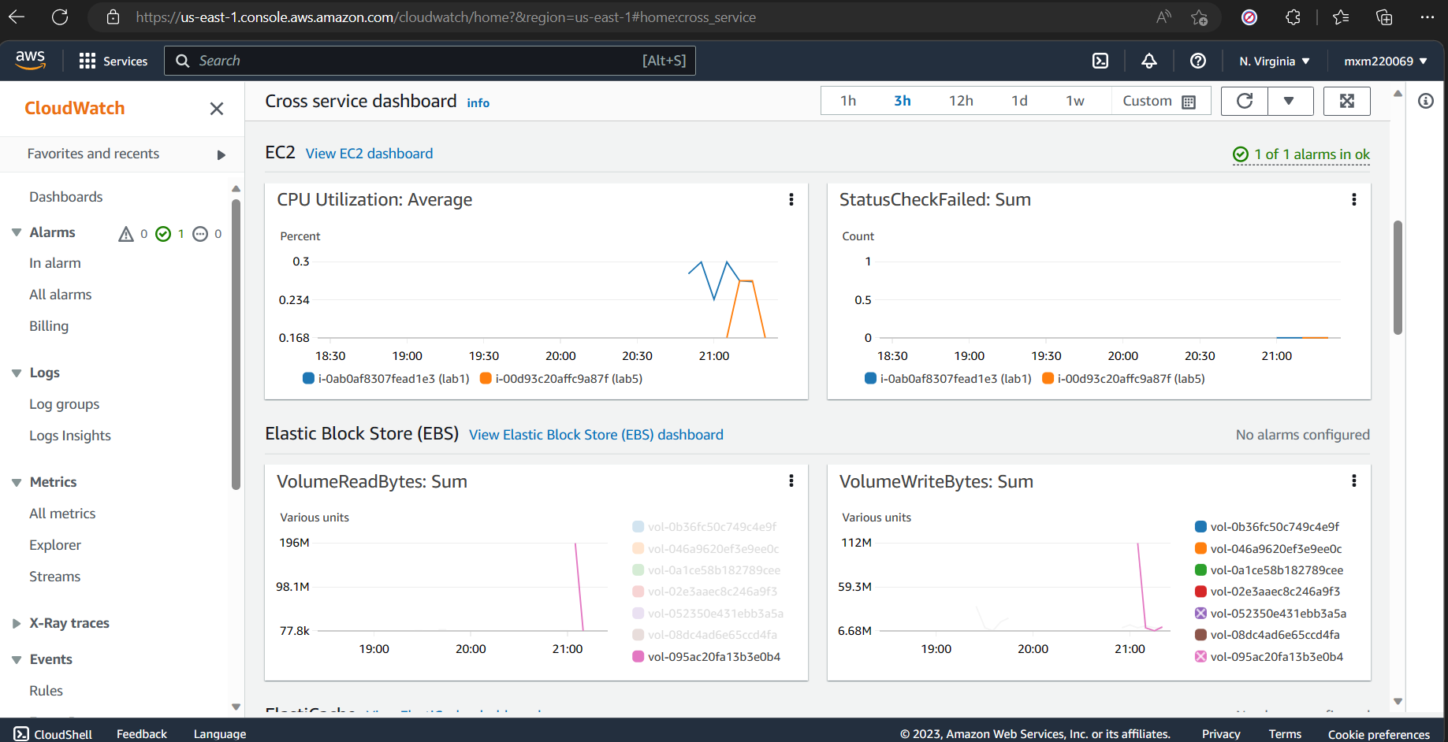

# Lab Chapter 2:

1. Screen shot of EC2 console showing running VM.

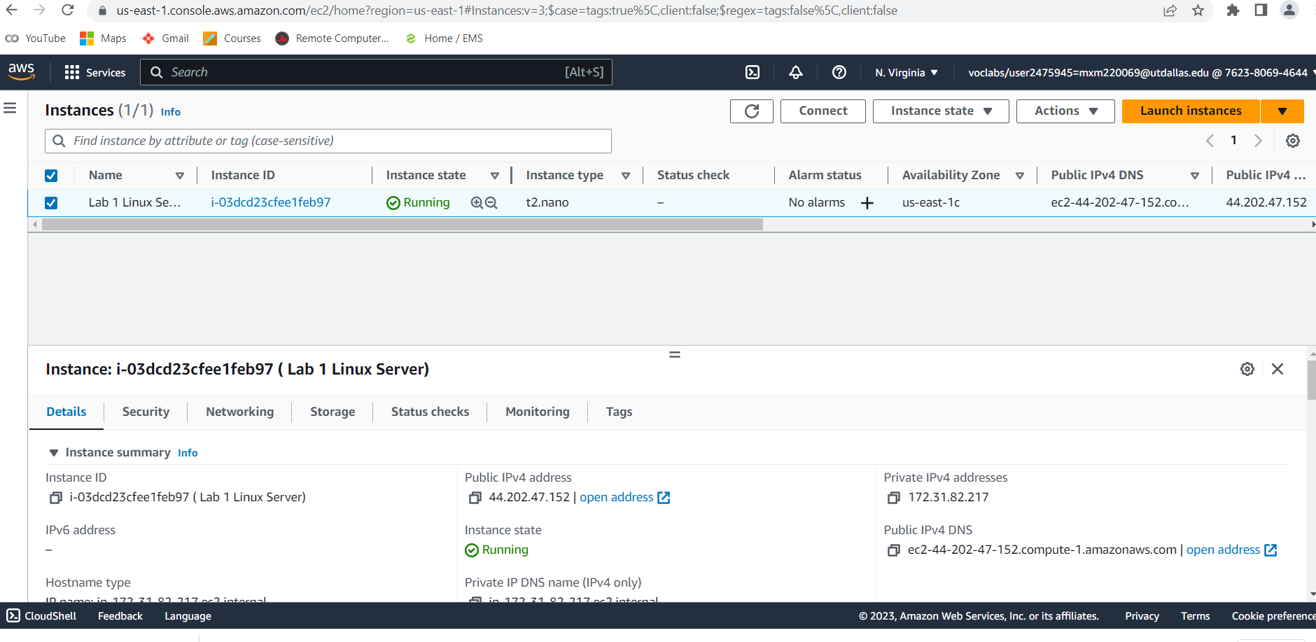

1. EC2 console shows the EBS volume that is the disk image for your VM.

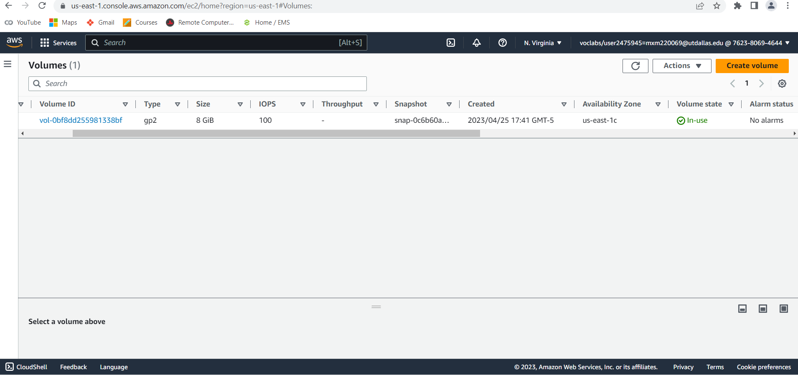

1. SSH console showing you logged into your VM and at the command prompt.

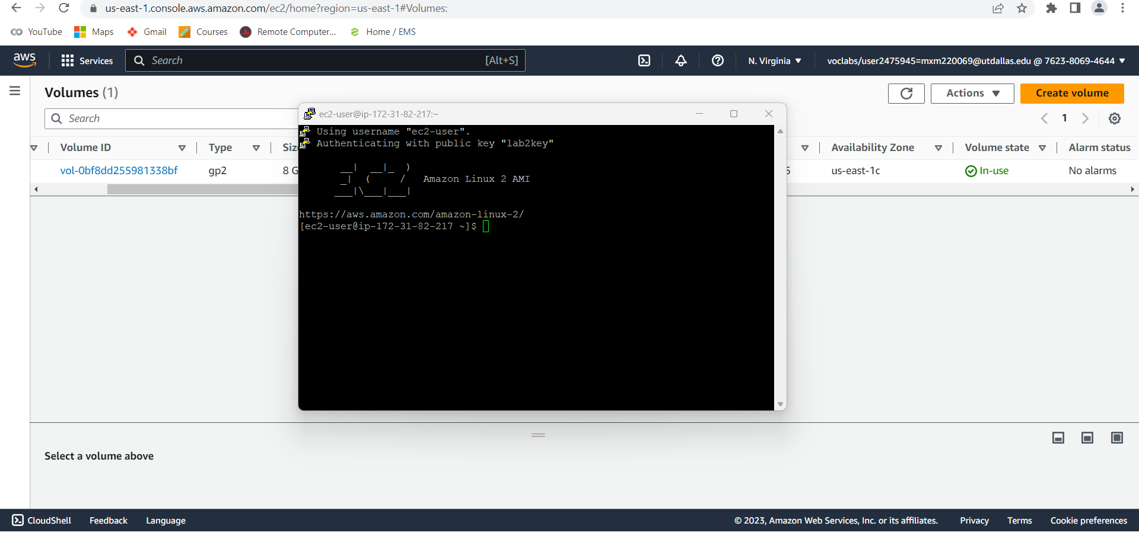

1. SSH console showing the required information.

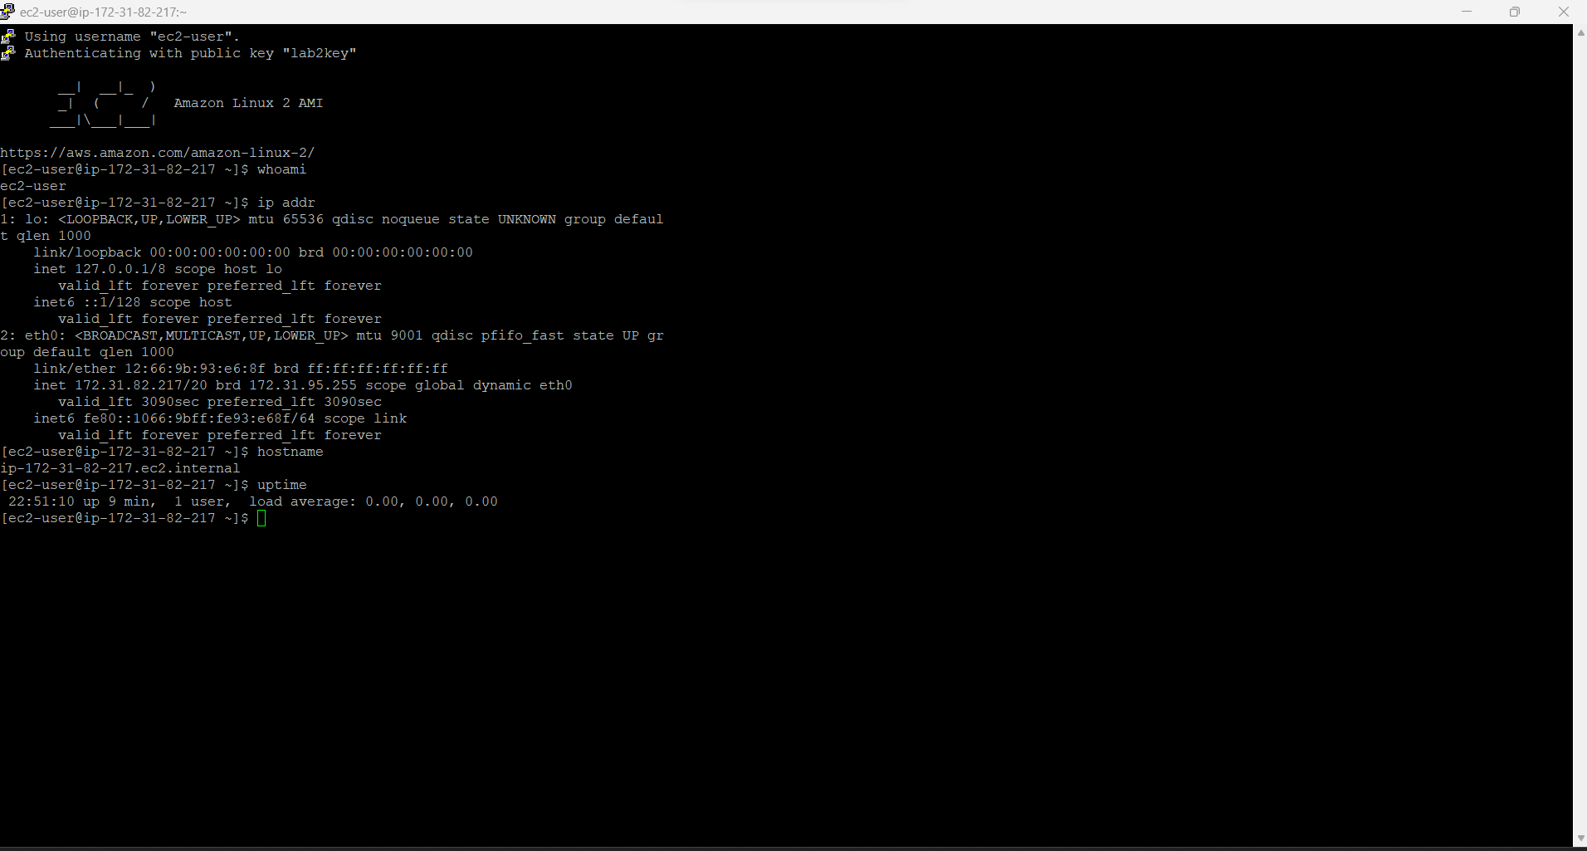

# Lab Chapter 3:

1. Connected to linux VM

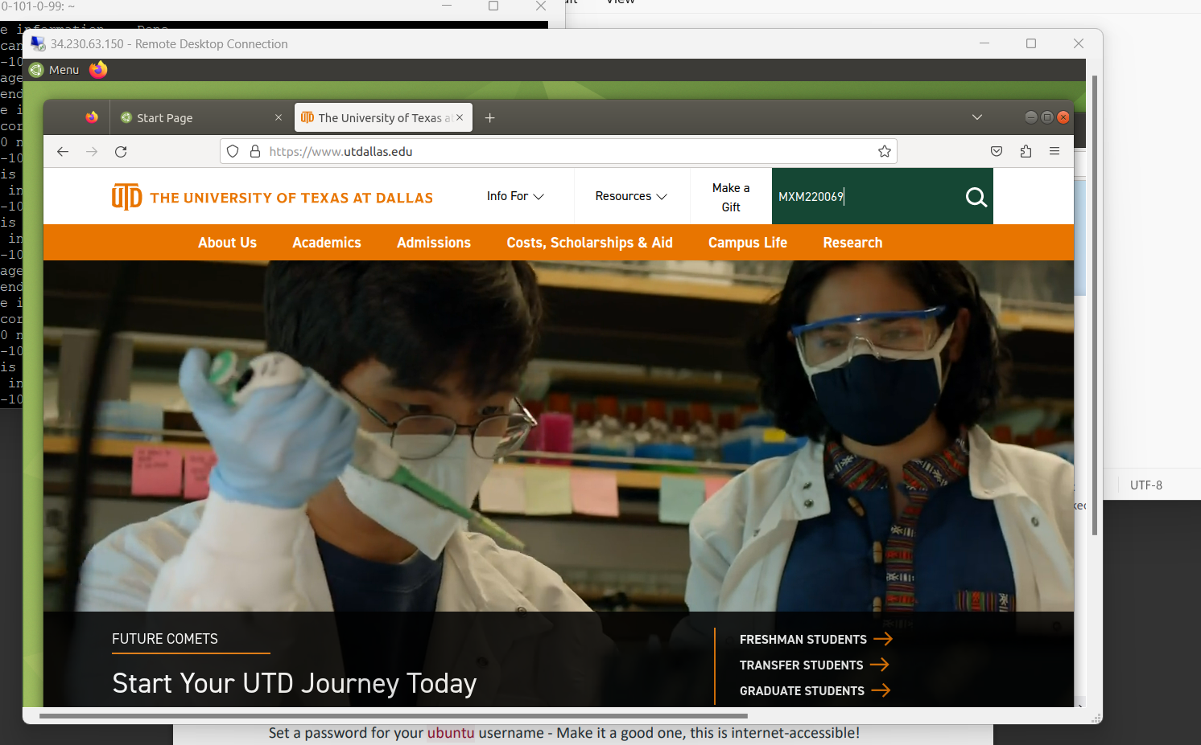

1. Stopped the instance.

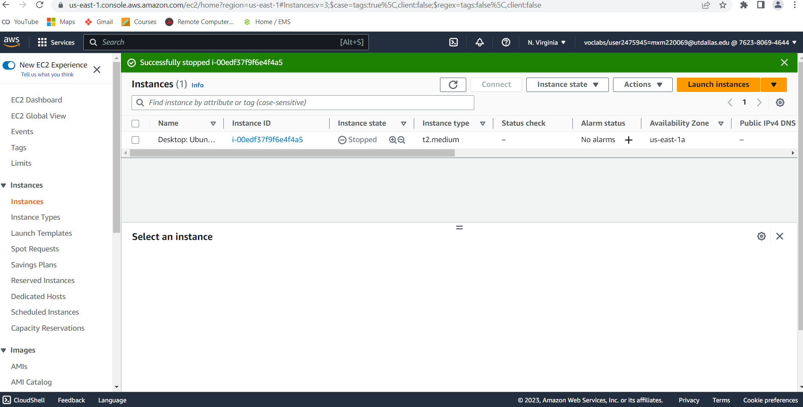

3.

An Amazon resource that can continue to accrue hourly charges after shutting down an EC2 instance is an Elastic IP address. Elastic IP addresses are static IP addresses that allow for dynamic cloud computing and can be associated with an AWS account. Once associated with an instance, the Elastic IP address remains allocated to the account until it is explicitly released. Failure to release the address upon shutting down the instance will result in an hourly fee. The Elastic IP address can be in the "Elastic IPs" section of the EC2 service dashboard. To avoid the charges associated with an unused Elastic IP address, one can either release it or associate it with a running instance within the account.

4.

AWS security groups act as a virtual firewall that controls inbound and outbound traffic at the instance level, based on specified rules. These rules can include criteria such as IP address, port number, and protocol. Security groups provide automatic enforcement of the rules, blocking any traffic that doesn't meet the specified criteria.

Although a security group specified in AWS provides a high level of protection, it's still recommended to configure a host-based firewall inside your instance's operating system as an additional security layer. A host-based firewall offers more detailed control over traffic by user or application and can help protect against threats from within the same security group or compromised instances. Therefore, while security groups can offer significant protection for your instance, configuring a host-based firewall is a best practice for enhanced security.

# Lab Chapter 4:

1. nginx version: nginx/1.18.0 (Ubuntu).
2. Website screenshot.

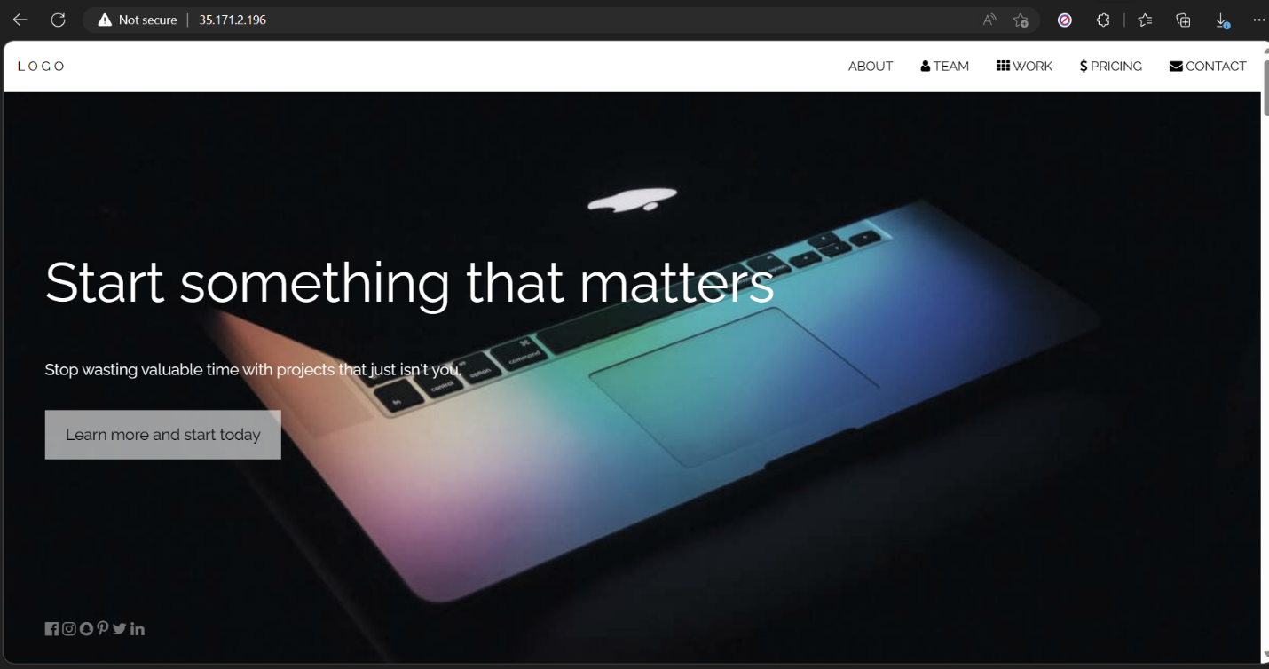

1. Performed the Nmap.

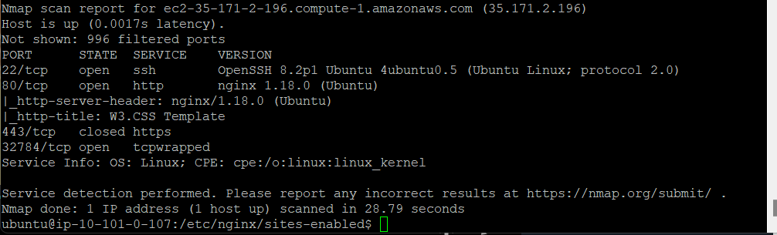

1. The Nmap scan can be used to scan a system's network ports and services and detect its configuration and potential vulnerabilities. Depending on the type of scan performed, it can identify details such as the operating system, open ports, and services. Comparing the results of the scan to the expected configuration of the system is crucial. If the system is designed to be a web server, the scan should show open ports for HTTP (80) and HTTPS (443) services. Additionally, the scan results can reveal security vulnerabilities that may exist on the system, such as open ports for outdated or unsecured services like Telnet or FTP, which can pose a risk to the system. If such vulnerabilities are identified, appropriate measures should be taken to secure the system. Lastly, the scan may identify information about the operating system and software versions installed, allowing system administrators to determine if updates are needed to address any vulnerabilities. In summary, analyzing the output of an Nmap scan can provide valuable insights into the security status of the system and assist in taking proactive measures to protect against potential threats.
2. Confirmed that the web server is set to start automatically at system boot, and that the OS is set to automatically apply security updates on a regular schedule.

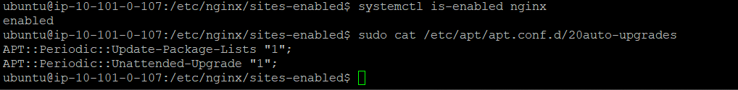

1. The use of automatic security updates in a server OS can save time and effort for administrators, while ensuring that security patches are applied quickly and consistently. However, automatic updates can also pose risks of compatibility issues or unintended consequences. Manual installation of updates provides greater control and oversight for administrators but may require more resources and time. The decision to use automatic or manual updates depends on the specific needs of the organization and the level of control desired for update processes.

4b.

Part 1:

Scenario 1:

Public link: <https://calculator.aws/#/estimate?id=8b31353c9265257e97503d24c3bff50de663fa1b>

Monthly cost: 3.60 USD

Scenario 2:

Public Link: <https://calculator.aws/#/estimate?id=e23935f4e0959ab8e49b6b964b437f09aacf2280>

Monthly cost: 7.50 USD

Part 2:

1. Two Ec2 instances running.

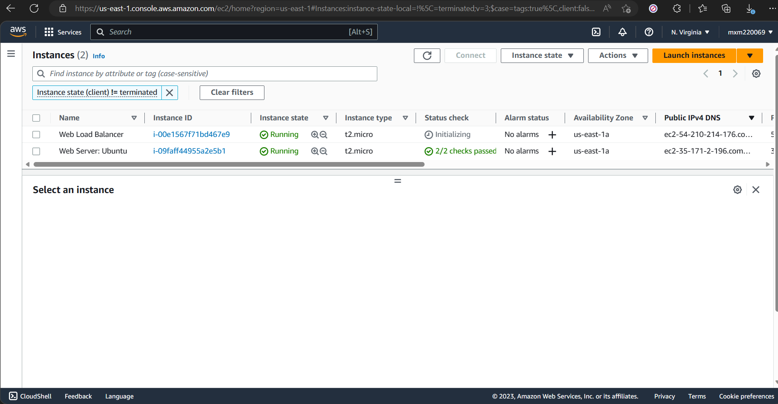

1. Load balancer DNS:



# Lab Chapter 5:

Created the estimate.

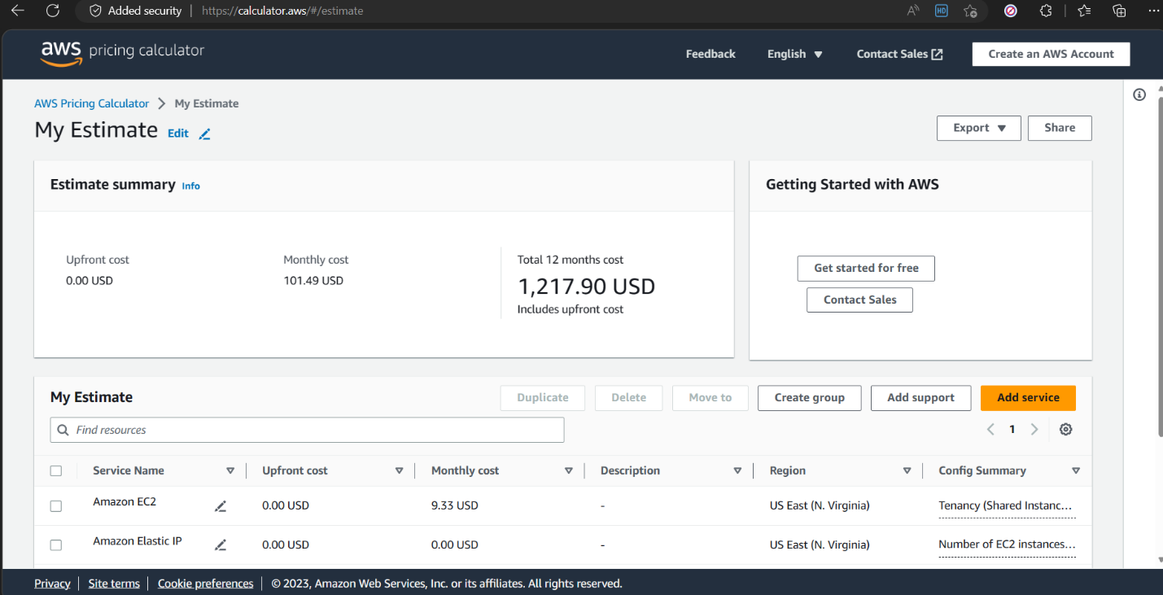

For Scenario 1: Private link to saved AWS pricing calculator for scenarios 1.

<https://calculator.aws/#/estimate?id=01dfa4466d17062b488f1daebe55b8b7fc7def21>

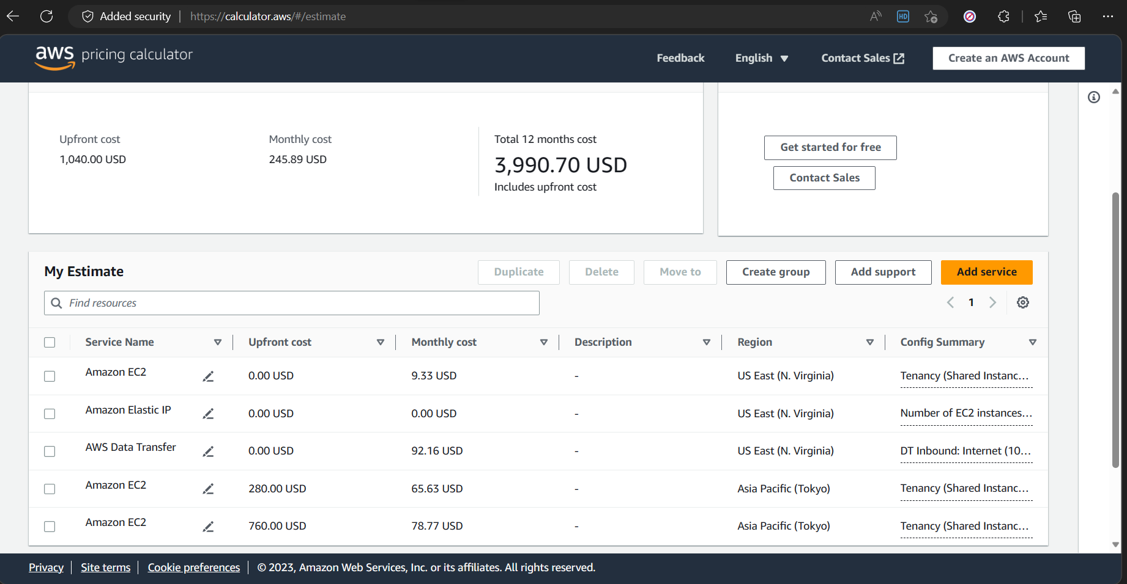

For Windows instance the price estimate is captured below.

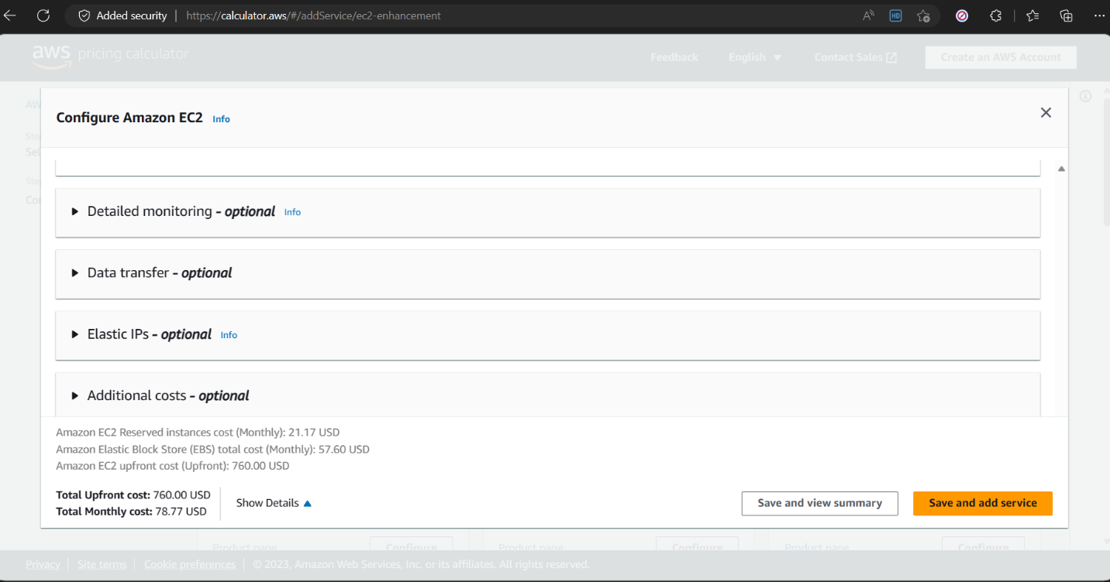

Scenario 2: Private link to saved AWS pricing calculator for scenarios 2.

<https://calculator.aws/#/estimate?id=1057ede3d1a4f49ab15919343db6c4b37beb2e23>

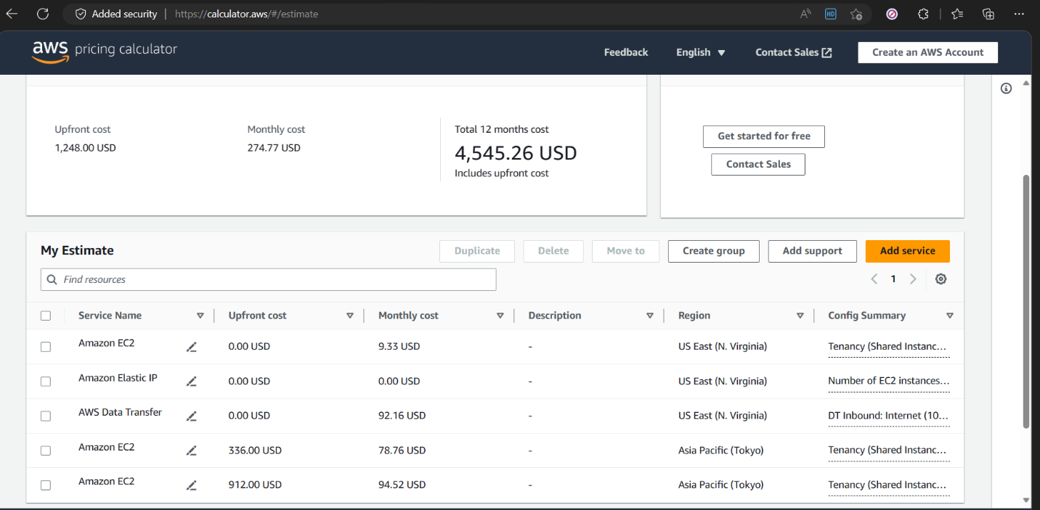

Cloud watch billing Alarm.

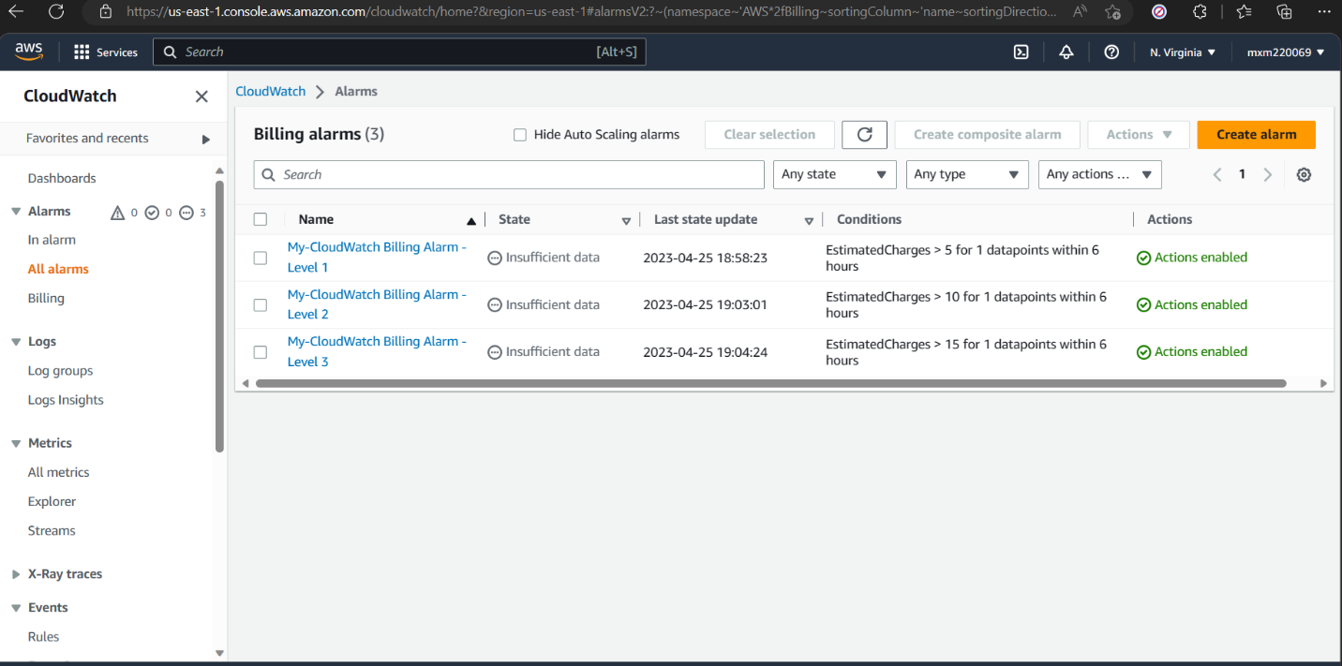

# Lab Chapter 6: Lambda Lab

**Run a Serverless "Hello, World!" with AWS Lambda**



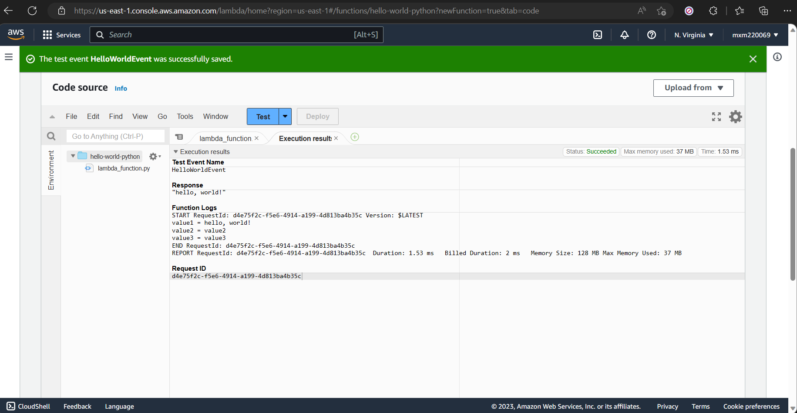



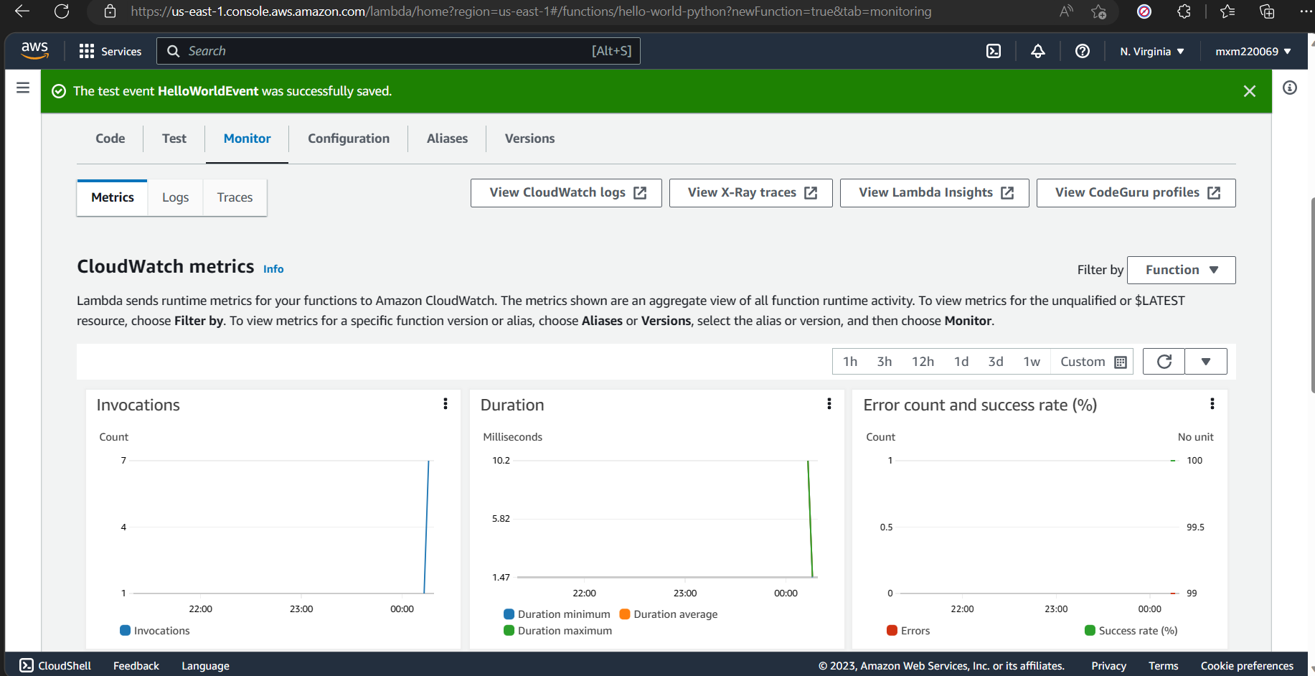

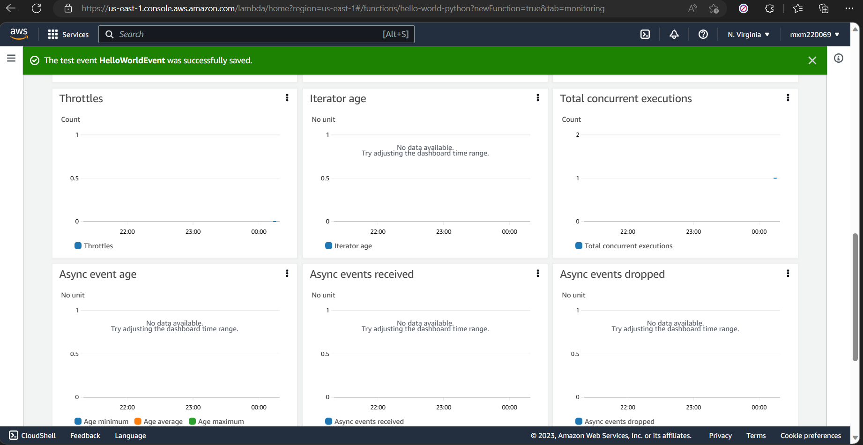

# Lab Chapter 7: Step Function Lab

**Schedule a Serverless Workflow with AWS Step Functions and Amazon CloudWatch**

Step 5:



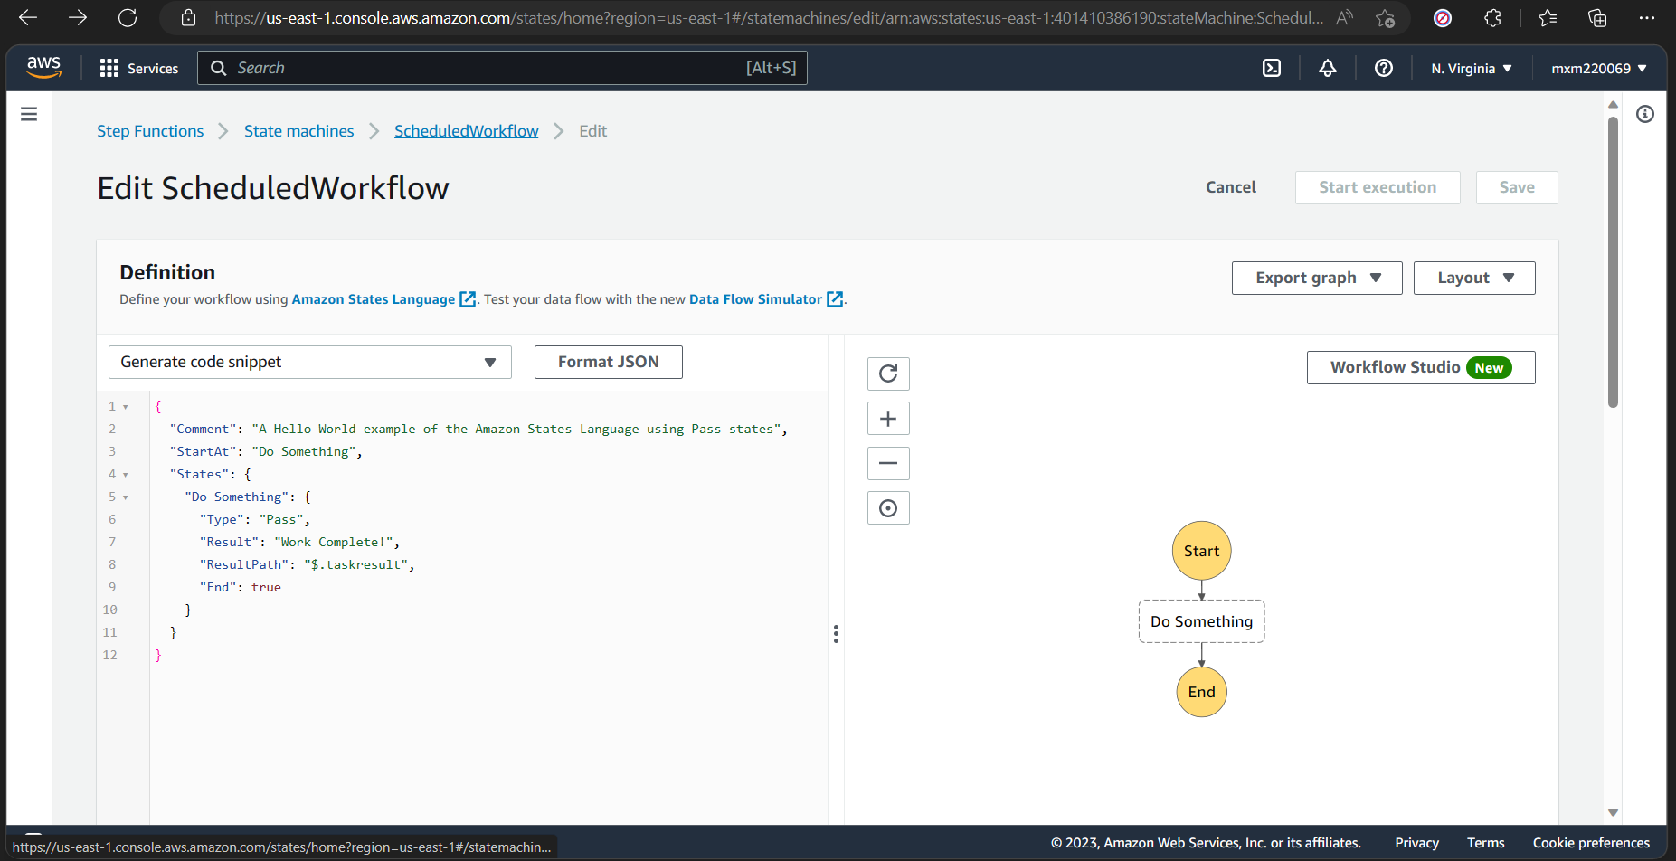



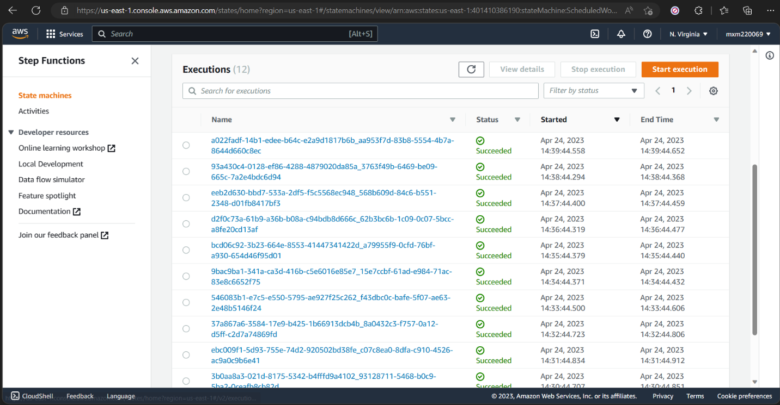



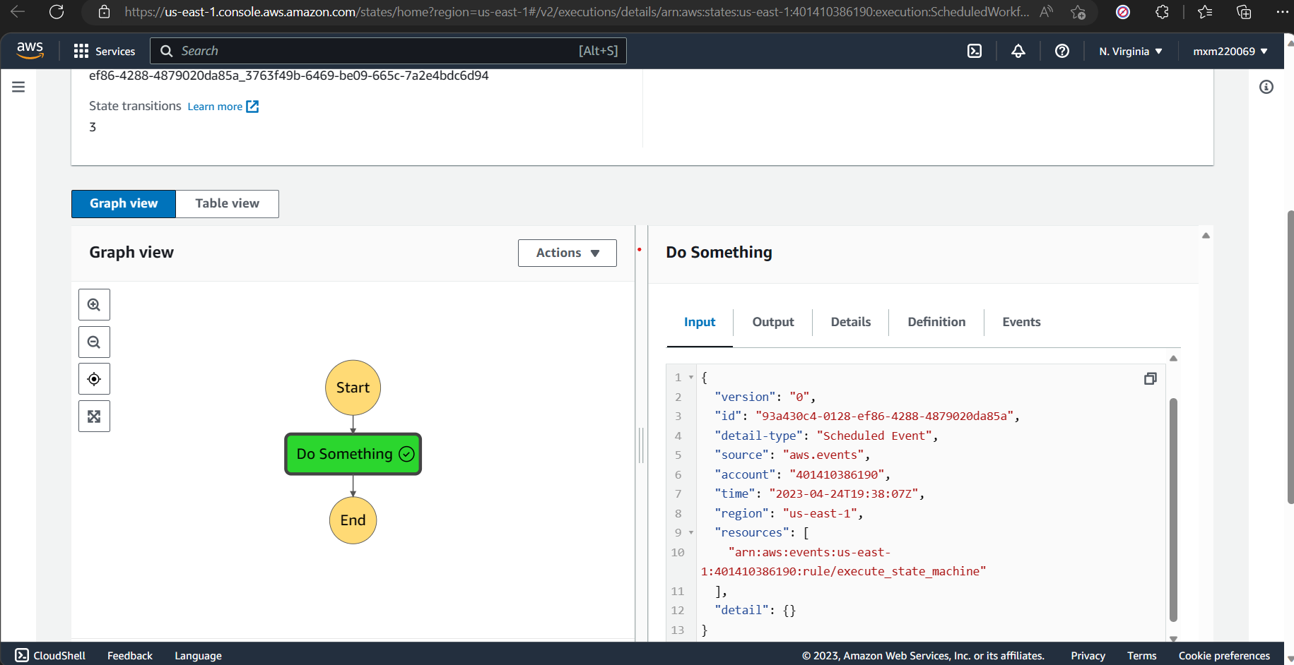

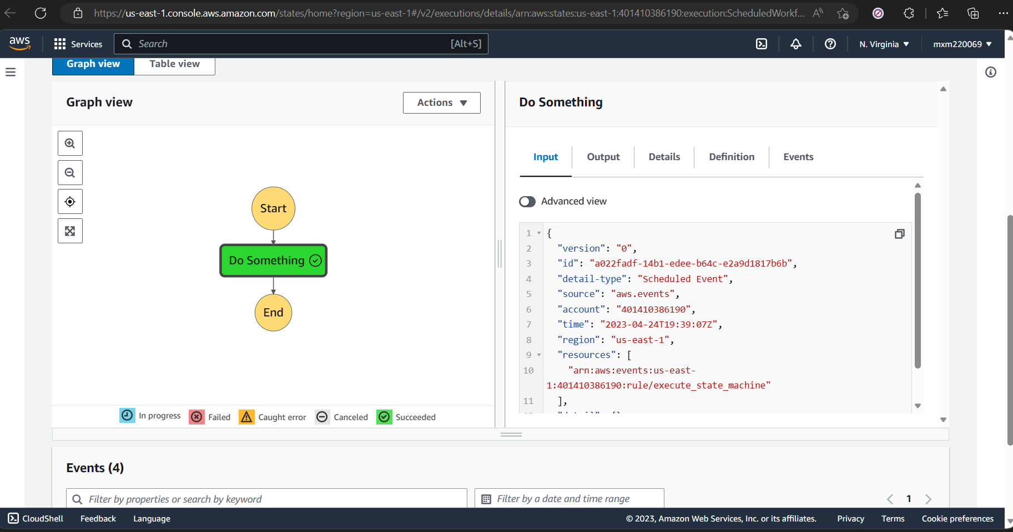



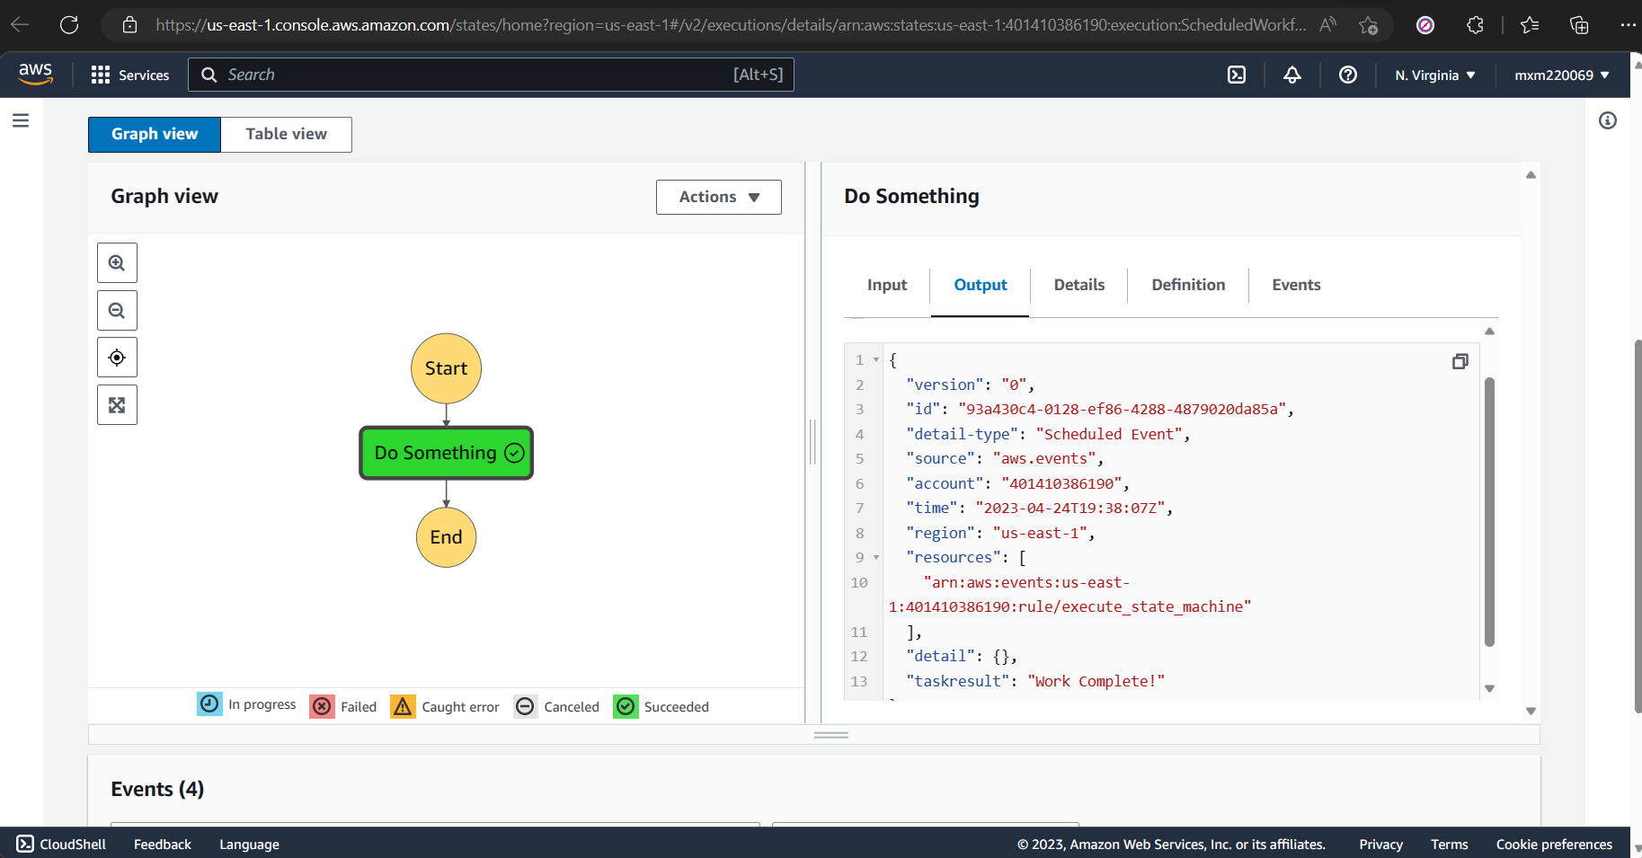

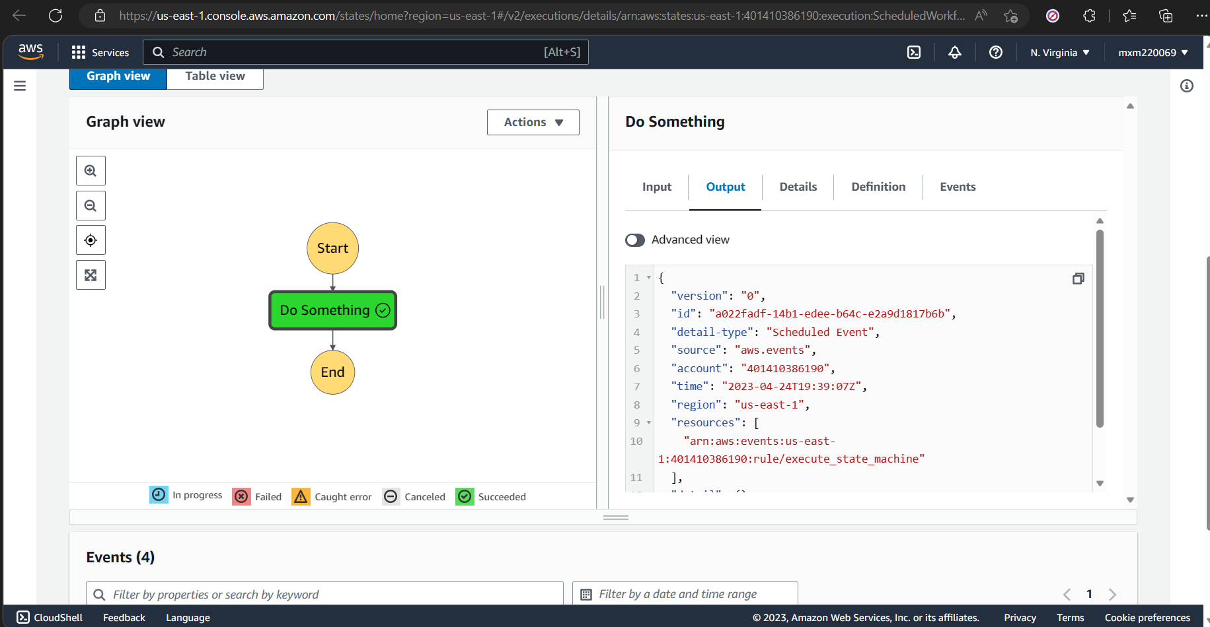

# Lab Chapter 8: Create a Redis Cluster

1. Captured last” Create screen” and “Redis cluster launched screen”.

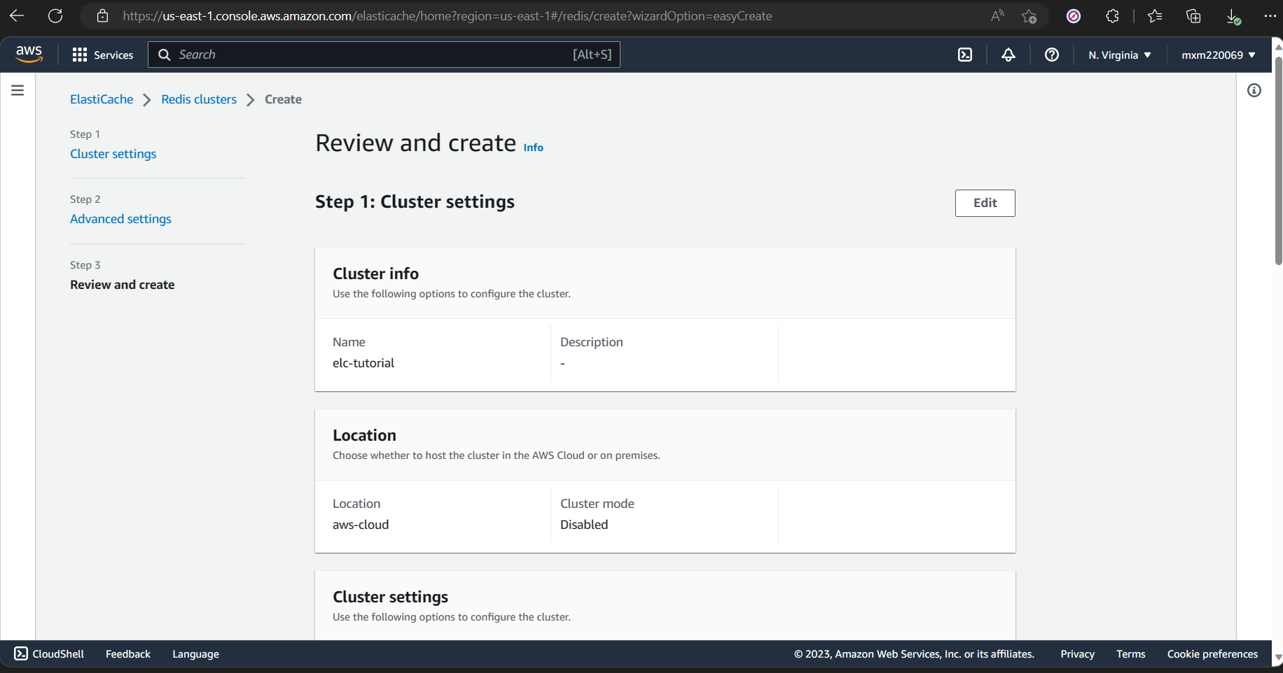

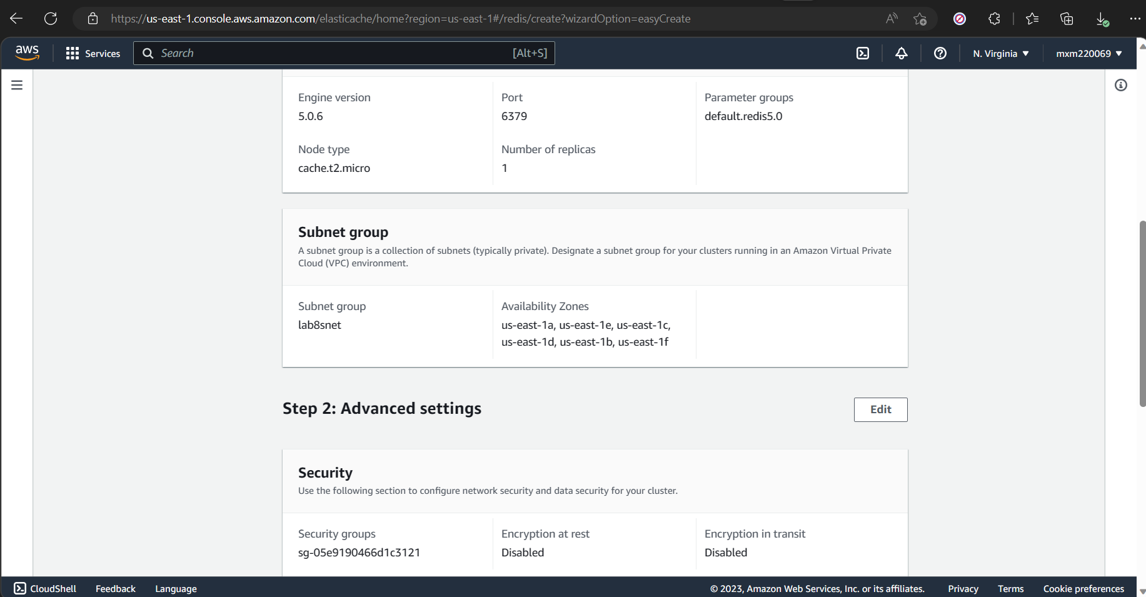

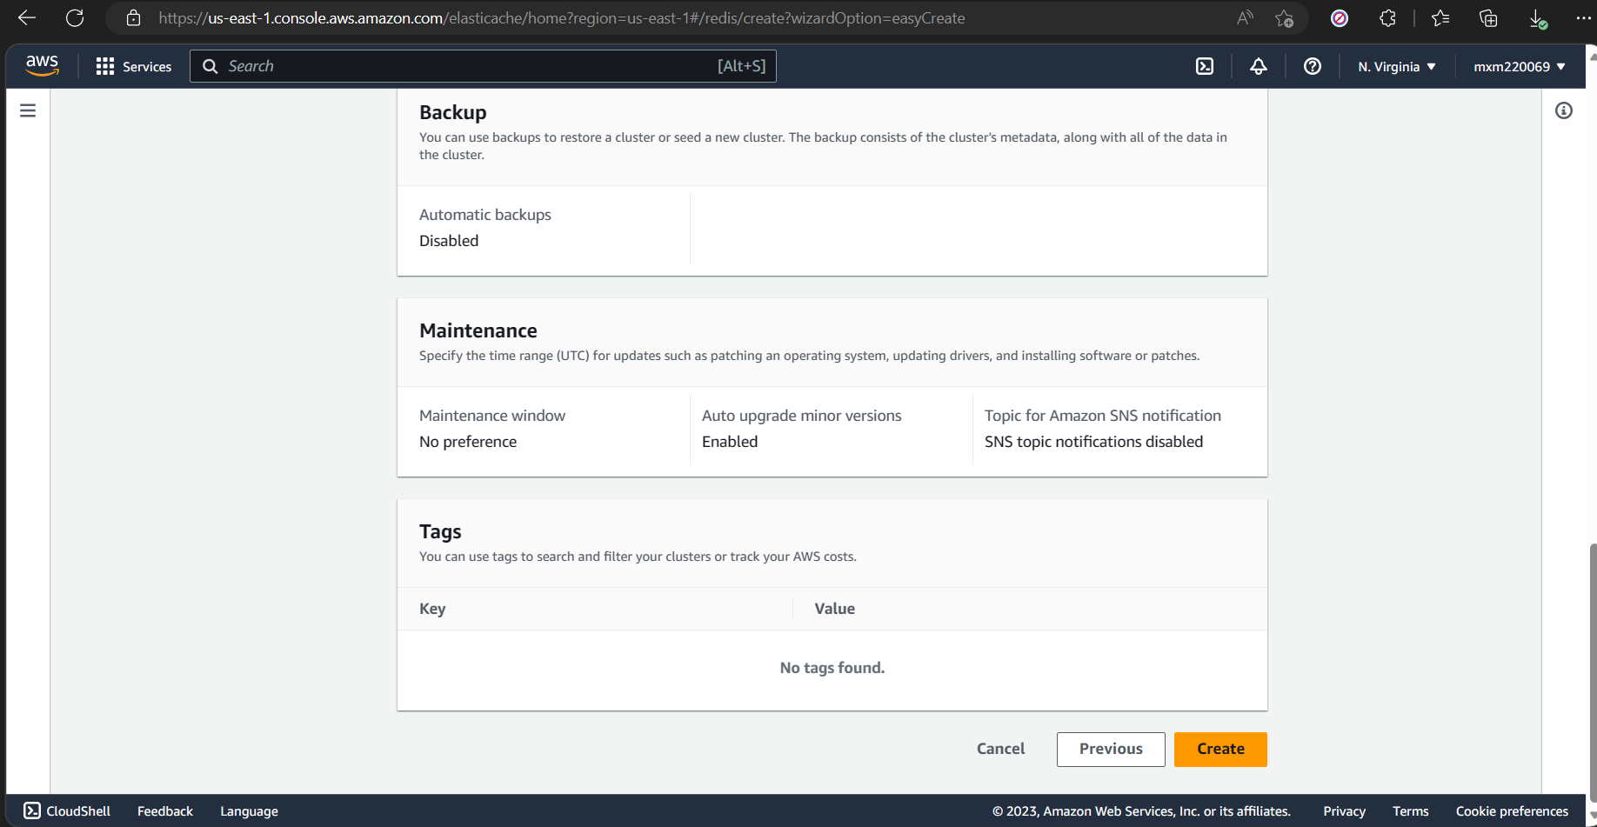

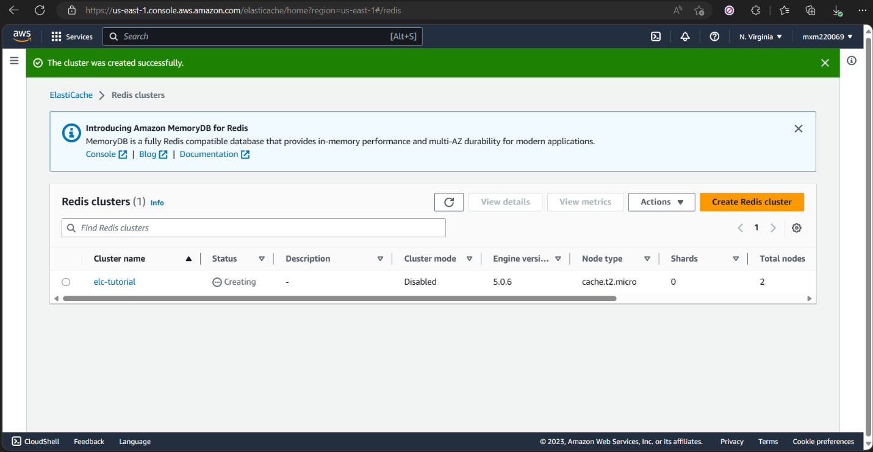

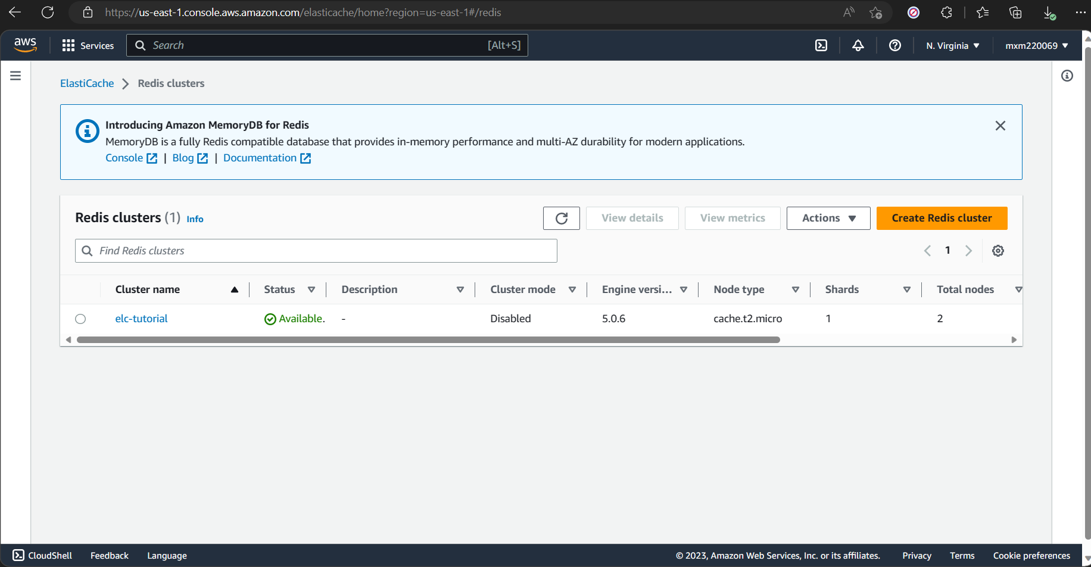

# Lab Chapter 9. Create Mysql database.

1. Captured Connectivity screen shots.

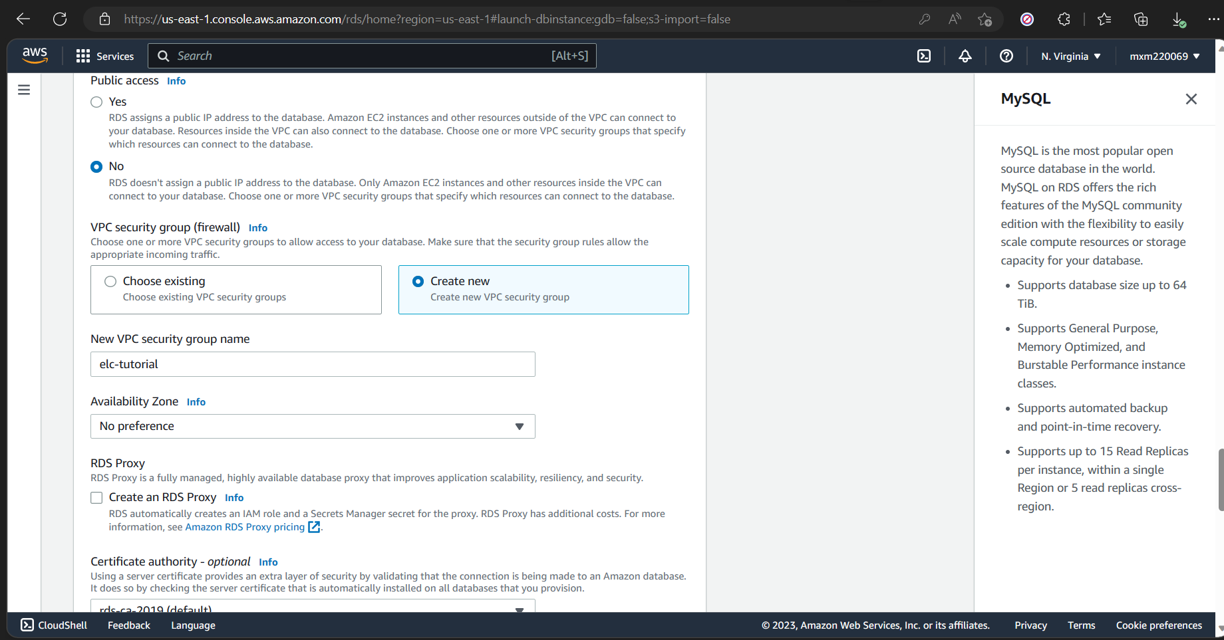

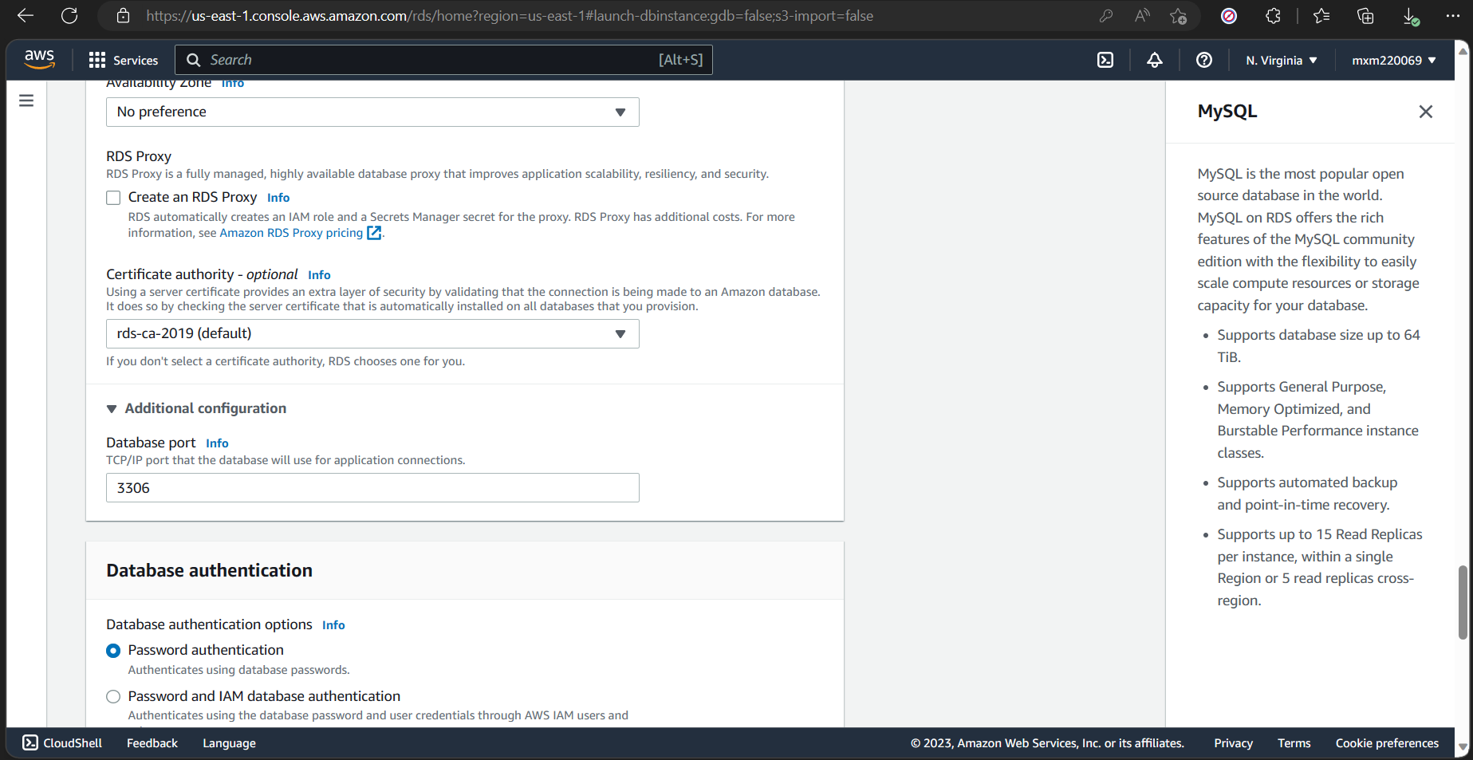

1. Captured review and create Database screen shots.

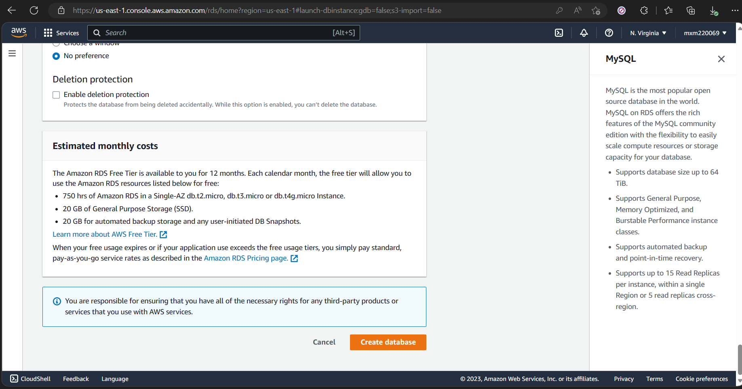

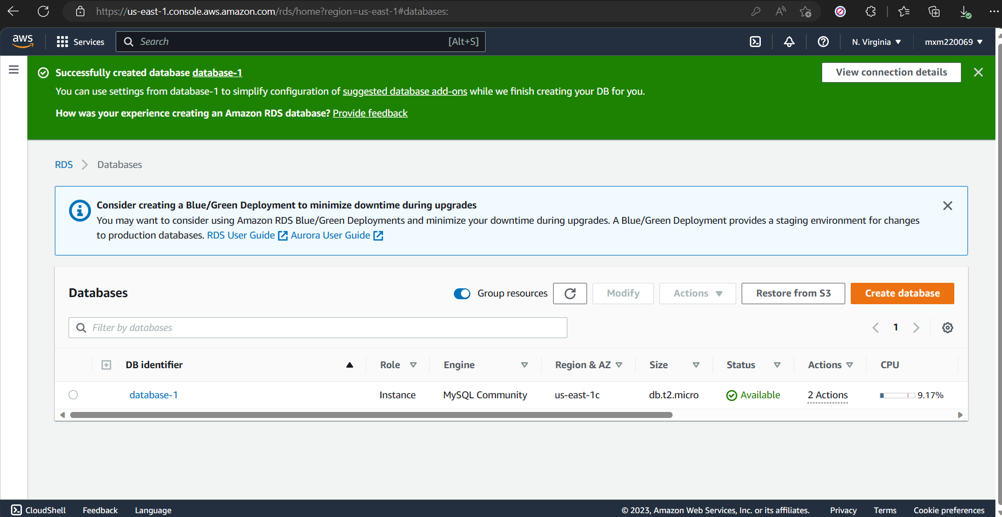

# Lab Chapter 10: Cashing

1. Captured the required screen shot.

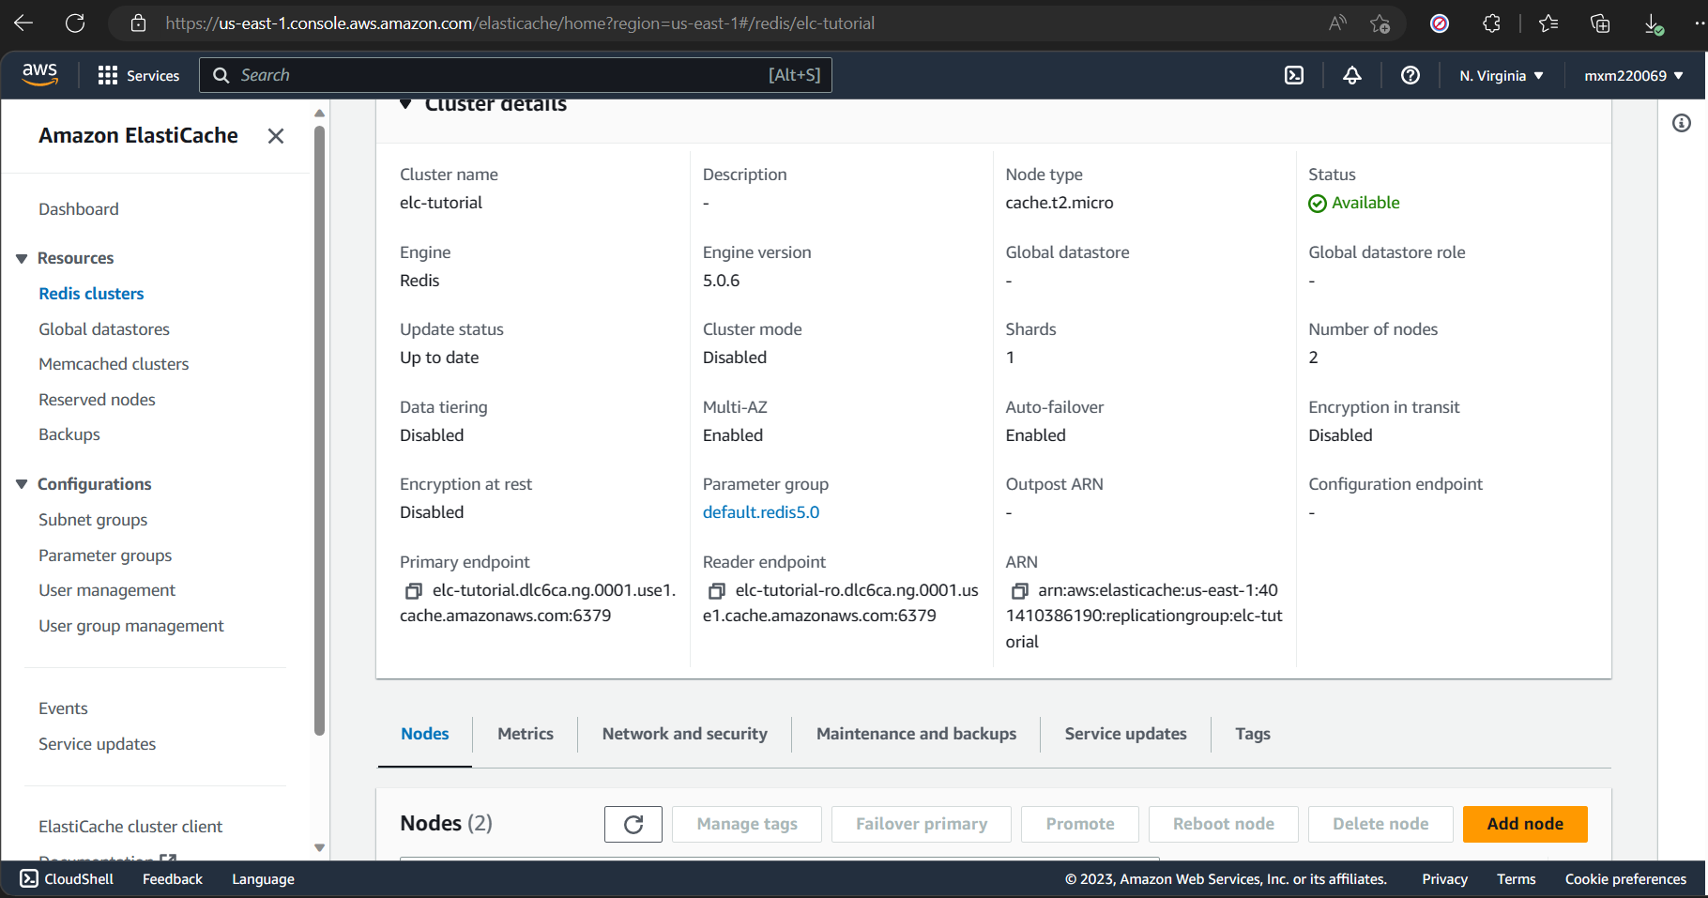

# Lab Chapter 16: Build, Train, and Deploy a Machine Learning Model with Amazon Sage Maker.

1e. Created a Sage Maker Notebook instance.

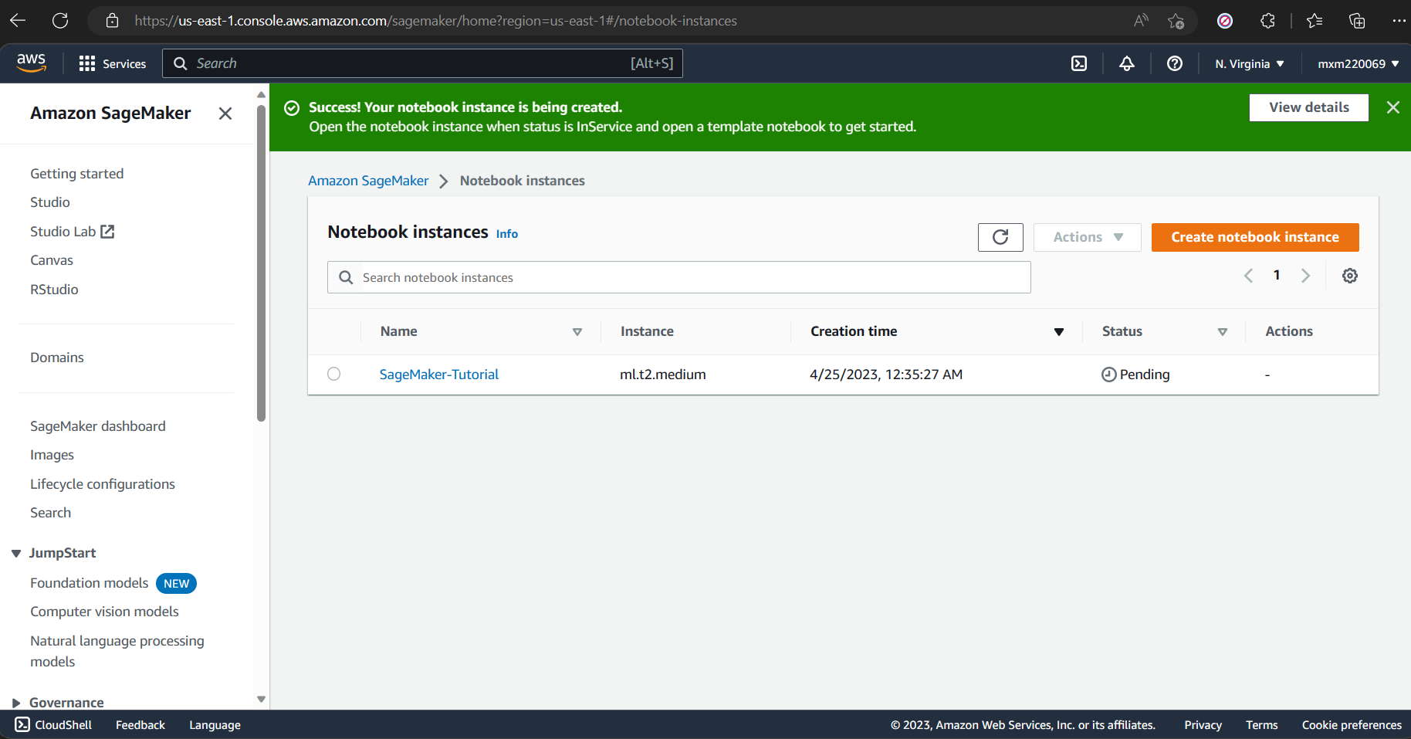

2f. Completed splitting data into train data and test data.

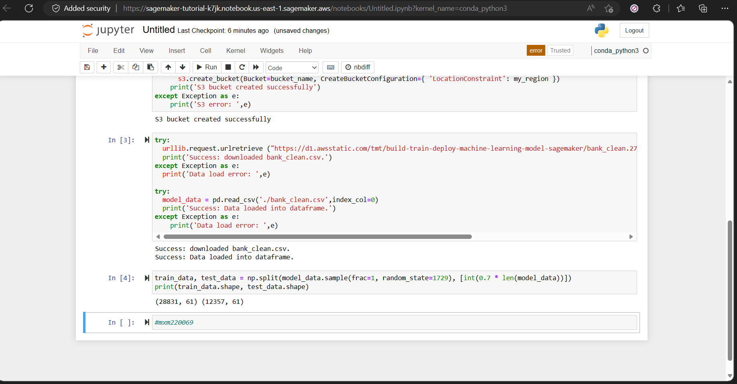

3c.

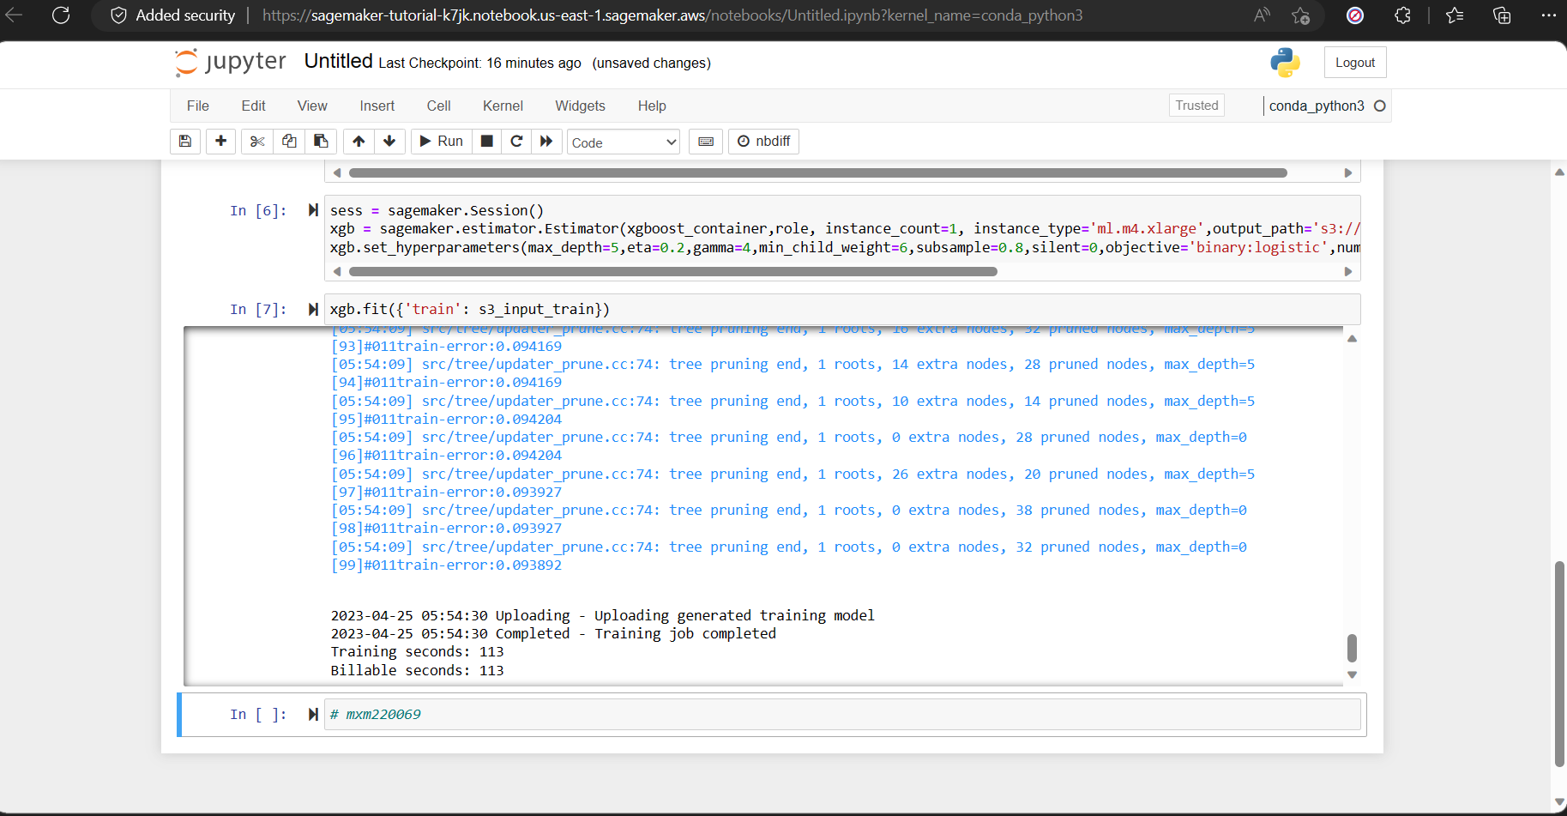

5. Executed the code and observed the output.

